WEB DESIGN
PROJECT REPORT

PROJECT TEAM
Student No. | Student Names
16108647 | Gilberto Caobianco Junior

** Insert Project Name Here **

** Insert Project URL Here **

Section 1: Design

- PROJECT PROPOSAL

Project Overview

In Brasil there is a sport using pipas (kites in english) called Kite Fighting.The Pipas in Brasil are different than the kites I have seen for sale here in Ireland. They are all constructed by hand using specialised material. This website will be about kites (pipas), with the idea of intorducing a new product to the Irish market.
The idea is to get the product well known, and to get the user to purchase items from the site. Because it is a new business and small, the only payment option at the moment will be cash. The Website will change and grow while the business grows, and at the same time the business will be learning and gaining experience.
The home page will give some information about kites and has the idea of trying to catch the curiosity of the user through this text and drive him to the next page, which is “Photos”, so after reading about the product now the user will be able to visualise it and have some pictures with description to look at.
So the third step after reading and visualising is to catch the user’s curiosity about the price which can be seen on the tab “Buy Now” where the user will have a chance to buy products either individually or in bundle packages.
Then we have a fourth page which is the “Contact” page, where the user can give us feedback, advice or criticise.
So at this stage I only wish to slowly introduce the concept of the Brasilian style kites in Ireland as I haven’t seen any competitors in the country with this product as a business.
The Website will have 4 pages, the main colours will be black, grey and white with some headers in red. Images have been provided with full permission of use. For building the website we need at least one CSS external file, three JavaScript functions, and HTML. The website also must be responsive.
Home page will consist of a navigation bar, background picture, a transparent text box area containing information about kites.
Photos page will consist of 8 images about materials needed for making a kite, the image of a kite already made, people playing with kites, and kites flying.
Contact page will have only a form with 4 fields and a submit button on the bottom, an important page for customer service.
Buy Now page will consist of kite pictures, material pictures, and bundle pictures with prices already calculated to be displayed just under the picture.

Research / Investigation

At the mometn in Ireland there are no competitors for my business, but I am taking examples of other business outside Ireland that are selling similar products.
The first one is called Castelo de pipas (Kite’s Castle) that’s the link of their website:
http://www.castelodaspipas.com.br/
Positives points about it that I like is the fact that this website is very simple and straight forward. Easy to read and easy to navigate it. The prices are well described under the image, so you can visualise what you are paying for.
Although I find several negative points about it. For example the navigation bar on the top is the same as the menu option on the left, directly below it, which I think is unescessary.
Some options of the navigation bar don’t have anything on it or they have incorrect links. After clicking the option it drives you to the next screen, but the name of the product on the navigation bar does not correspond to the item displayed. Ex: if you click on papagaio (a type of kite) the next screen shows information about delivery, and that works the same for many other items.
Also the site is advertised as kite’s castle but it sells mainly the special string used for controlling the kite. It doesn’t focus in the main product which is the kite or all of the componants needed to make a kite.
The second one is called Loja Mais (The Plus Store) and that’s the link for their website:
http://www.lojamais.com.br/loja/emp_bodyhome.aspx?codemp=20978
Positive point about if compared to the first one, is that it looks a bit more fancy on the visual side, its another super simple and straight forward page with images and prices well described. Also the display of images changing automatically looks cool and shows a bit more effort involved.
Negative points: There is a panel slider numbered from 1 to 9, and there is 9 images above so when you click on the number it supposed to show the image that corresponds to it’s number, the problem is if you are on number 1 as for example, and click on number 9, instead of showing straight away image 9 it goes up one by one all the way to number 9 showing all images. Apart from that there is not much to talk about because the page is very simple and not much to be navigated.
The third one is called Planeta das pipas ( Kite’s Planet) that’s the link of their website:
http://www.planetadaspipas.com.br/
Positive Points: Between all three sites researched this is the best one. It has a good combination of colours, a cool navigation bar, with one of the items showing as a dropdown. The website is responsive and you can easily see all of their products and prices. The search options works just fine, also there is a check box on the right side with 3 options.
The hover over function in the menu navigation bar works nicely too, changing the color of the option that your mouse is pointing at.
Negative Points: This website is called kite’s planet when translated, but there is much more about other mixed product than kites or material for kites. Actually there very little about kites overall and much more option for other stuff not related to kites at all.
Their logo on each picture isnt well displayed, looks messed and all blurry. It is possible to notice the logo, but hard to see it.
The idea I got from my research is that all pages are simple and straight forward, which suits me as a beginner in web development. I didn’t see much information about kites in any page which I will provide on mine so the customer will have a better idea what is about. Also i will provide images so the user will not only read about the kites but be able to see them too, and that should improve the chances of getting the user’s curiosity to complete all the steps and purchase from the site.
All websites selling materials for making kites or kites made already, have images with the prices below. That’s very important and I will use it.
So the general idea is to have a home page with some text which will be information about kites, and what it is about, that should get the user curious about what was read and drive the user to the second page. There will be displayed images of people having fun with it, and it should lead the user to the third and final step which is completing a purchase or contacting us through a form where the user will be able to give advice, criticise, or raise any question about kites.

Requirements & Technical Approach

The requirements are :
• The site should have a minimum of 4 HTML pages ► ** Your home page should be called index.html **
• Site styling controlled by at least one external CSS file
• Clearly defined, consistent, navigation system
• Website must be responsive
• Use of JavaScript (minimum 3 examples)
• Website Deployment

My first approach is to make sure of my resources, I will make sure that I can use the images required for the website and that they are royalty free. I will make sure that I will use my own code and that I will be able to explain the code later. Also I will open a github repository for keeping it safe and backed-up, and to prevent from any risks or accident. That way I don’t lose any progress. Once I have all resources checked I will build up the wireframe for the project.
Last step is to start building the website following the requirements, testing it and in the end take the website against the requirements list.

WIREFRAME / SITEMAP

** Include wireframe, and sitemap, for your website here, including brief explanations where needed, etc. **

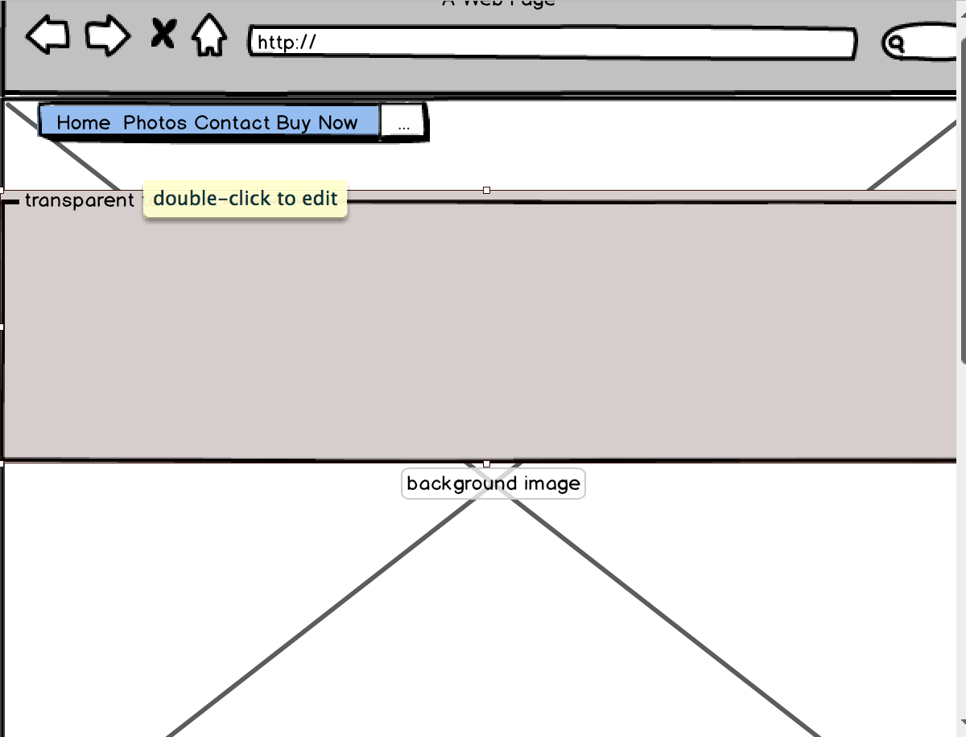

Home Page: Navigation bar on the top left, with a background image and a white box almost transparent for some text introducing the website.

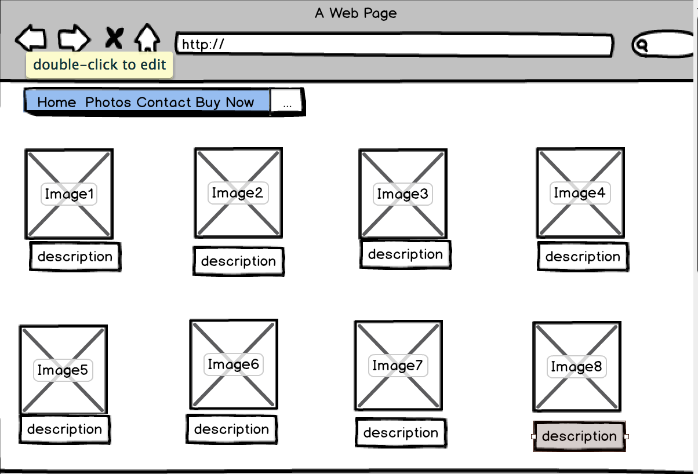

Photos page: navigation bar, with 8 images and 8 little text box below it.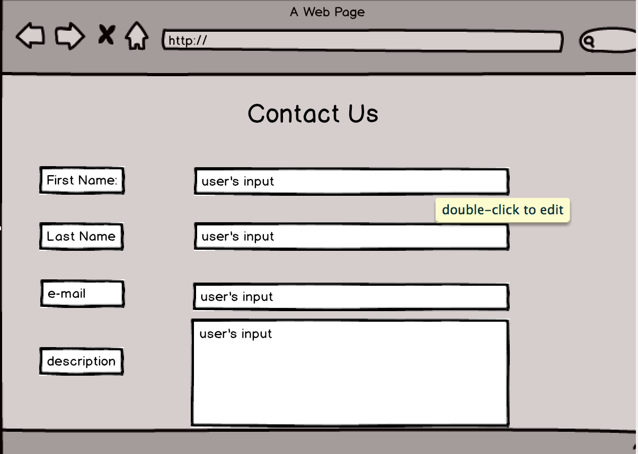Contact Page: four fields for the user to input data and message.

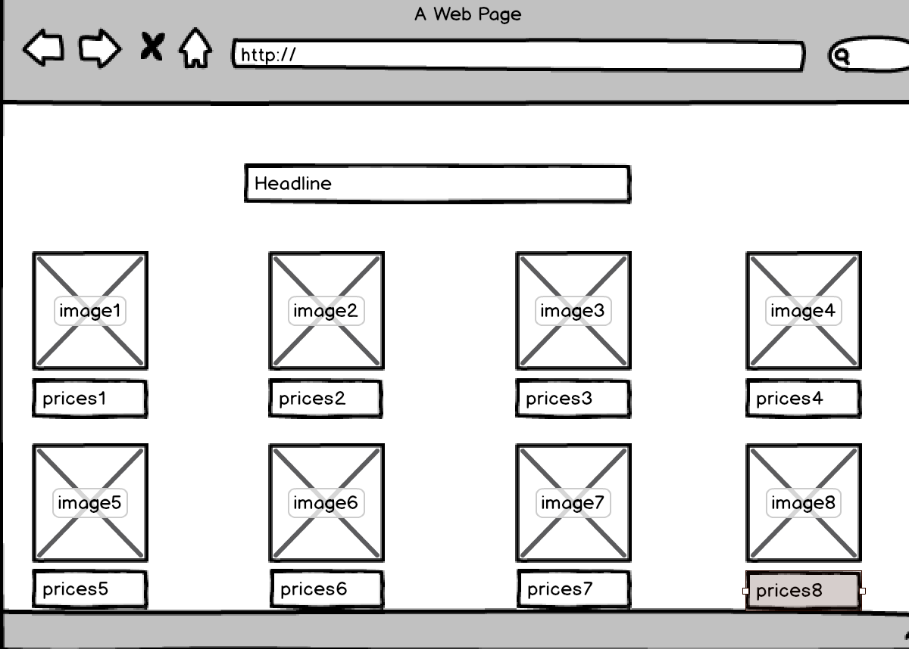

Buy Now Page: A text box in the centre, 8 images with 8 text box below for prices.

****** The following sections should NOT be completed until you have FINISHED your website ******

Section 2: Development

- PRODUCTION LOG

** This section should outline how you went about developing your webpage, i.e. HTML, CSS, JavaScript. This should include information on requirements implementation, code development and technical details, such as errors or development issues and how you fixed these.
Please note: Make sure to include explanation (as well as comments in the HTML files) of any & all code that was taken from the web, or you will not receive marks for this third party code. **

Validation

** This section should look at validation of the website, were you able to validate the website, were there any errors and if so, how did you go about fixing them. Please include a screenshot(s) of your validation report here **

Deployment

** This section should include information on your choice of deployment, as well as the sites URL and a screenshot of the live site **

- PROJECT TEAM

** How did the project team break up the tasks required?
Who did what tasks? Did everyone evenly participate?
Were there any team issues? Etc. **

Please note: You will each be asked to individually peer review your team mates privately via Moodle also

- CONCLUSION

** Having finished the project, looking back, how did the project go?
Did you achieve what you set out to do?
Are you happy with the results?
Is there anything you might change if you had more time? Etc. **

- REFERENCES & APPENDIX

** Make sure to include any third party resources / information / code used here.
Make sure to reference correctly as needed, i.e. Harvard Referencing, or marks will be deducted. **

